Smart Navigator Architecture Document
IBM Confidential – Internal Distribution Only
Revision History
Date | Revision | Reason for Change | Author
02/10/2017 | 1.0 | Initial Draft | Luciano Dantas
20/2/2018 | 1.1 | -AD Review Updates  -Removed references to Rest | Tom Delahunty
21/2/2018 | 1.2 | Updated the Security section. | Luciano Dantas
Contents
Project Description 2
Prerequisites 2
Rationale 3
Requirements 3
Non-Functional Requirements 3
High-Level Design 6
Project Impact 14
Implementation Details 15
Customization 16
Development Considerations 16
Test Considerations 16
Documentation 17
Historical Information 17
Architectural Decisions 17

Project Description
Targeted Release(s): 7.0.3

Summary

Improve the current application banner search adding new features such as:

Smart Navigator field to support autocomplete suggestions:

Currently, the results are displayed in a new tab. To improve the overall user experience of the search, the new search is going to display the results as the user types the query. The results are displayed in the format of a drop-down list.

Direct Link to go directly from a search result to the target page:

The user will be able to ask for a person screen directly from the application search. If the user types “James Smith Cases”, then all cases of James Smith are going to be listed in the new drop-down list. The user then will be able to go straight to his cases from the search.

Another possible search could be “James Smith Evidence”. In this case, the user can go directly to James Smith’s Evidence page.

New search targets

Search Person by name, alternate Id and date of birth.

Search Person cases.

Search for common screens such as Person Evidence, Person Eligibility and Outcome Plan

New search targets can be added as part of the customization:

It should be customizable so that any screen can be added to the application search.

Key Contacts
Project Manager | Aleksandra Prodanoska
Business Analyst | Antoinette Reade, Alan Kenny
Technical Lead | Luciano Dantas
QA | Shyam Thkur
Developers | Thomas Delahunty, Yaroslav Frantsev, Fabrice Niclot

Prerequisites

No pre-requisites for this project.

Rationale

The caseworkers need to access the information quickly to better serve their clients. Currently, they have to go through multiple screens to access certain client information within SPM.

To access a common screen like outcome plan, the user needs to go through three tabs. It is a time-consuming process that can take up to fifty seconds.

This enhancement intends to improve the application usability, reducing the number of clicks the user must do to access the screens.

Requirements
- Search field in the Application banner that provides autocomplete, listing people or pages of the application that matches the input query. Each item of the list should have a direct link to its page.
A search target must be configured to each supported page. A set of predefined keywords is used to match the query to a search target.
- Search for a person based on the following criteria:
- First name and surname. Optionally the date of birth can also be added.
  - Alternate Id.
The search must follow the same rules as the existing platform’s person search.
- Supported search targets by default:
  - Case.
  - Eligibility.
  - Evidence.
  - Outcome Plan.
- A customer must be able to add new search targets, allowing them to specify keywords for new targets and introduce their own search algorithms.
- Existing search implementations within this feature (e.g.: Person search, Person’s cases) can be replaced by the client’s own implementation.
- The feature must be optional for customers, and therefore will be configurable to be turned on or off via administration. If turned off the Application Search will revert to the existing feature which will continue to work as expected.

Non-Functional Requirements

Detailed Non Functional Requirements

Accessibility

The Application Search must address all the items expected in the Web Accessibility Verification Test (AVT):
- AVT 1 - Use of automated Testing Tools: In Curam, we should use RPT-DAP.
- AVT 2 - Manual Testing - High contrast, keyboard, focus, browser zoom.
- AVT 3 - JAWS Screen Reader Testing.
- AVT 4 - VoiceOver Screen Reader Testing.
Refer to the AVT Documentation for more details.

Globalization
The search field must be designed to support tablets and Right-to-Left languages.
The application search relies on a set of predefined keywords, created as code tables, to identify what page the user wants to go (search targets).
This feature uses the code tables infrastructure to use the appropriate keywords based on the user’s locale.

Performance and Scalability
The search must be completed according to SPM internal SLA:
- 1 second for the server side transaction to complete;
- 2 seconds for the entire transaction to be completed.

Items to be considered:

- Do not call the API on every keystroke. The keystrokes must be grouped into a single call every 500ms.

Usability
The main goal of this project is to improve the user experience. It should bring a major improvement to the overall usability in SPM, but there are also a few things to be considered in the application search field usability:
- The user must be able to perform all the actions using only the keyboard.
- The user must be informed when the search is being processed by the system.
- Every item from the results list must be clearly identified as a clickable link.
- The result items must be self-descriptive and contain enough information to identify the related person;
- A message must be showed when the search returns more results than the results limit.
- If the user types any keyword, it must be clearly highlighted in the search results.

Security

Users should only be allowed to access pages that they are authorized for. If a user does not have access to a search target that target should not be displayed in the results.

We must rely on the existing security infrastructure. The authorization for search target will be based on SIDs.

Standard Curam Support for Non Functional Requirements

Non Functional Requirements
Standard Cúram infrastructure support can be relied for the following Non Functional Requirements:

Non Functional Requirement | Applicable | Comments
Accessibility | -
Availability and Resilience | Yes
Development Resource | Yes
Evolution | -
Globalization | -
Location | Yes
Performance and Scalability | -
Regulation | Yes
Security | Yes | Please see security subsection below for discussion on how the feature integrates with and uses the Cúram infrastructure to provide security support.
Usability | -

Functional Requirements
User Story |  |  | Description
217386 |  |  | Quick Search Keyboard Support
217384 |  |  | Quick Search Language Support
217382 |  |  | Delete Search Target Keywords in Enhanced Quick Search
217381 |  |  | Add New Search Target Keywords in Enhanced Quick Search
217417 |  |  | How returned results are displayed
217406 |  |  | Display of Person first and last name in person search results
217400 |  |  | Display photo of person for person search
217399 |  |  | Self descriptive display of person search results
217379 |  |  | Modify Search Target Keywords in Enhanced Quick Search
218407 |  |  | Display of available keywords in Enhanced Search
217419 |  |  | Combobox selection for enhanced quick search
217412 |  |  | Display of persons address in person search results
217377 |  |  | Browser Support

High-Level Design

Functional View

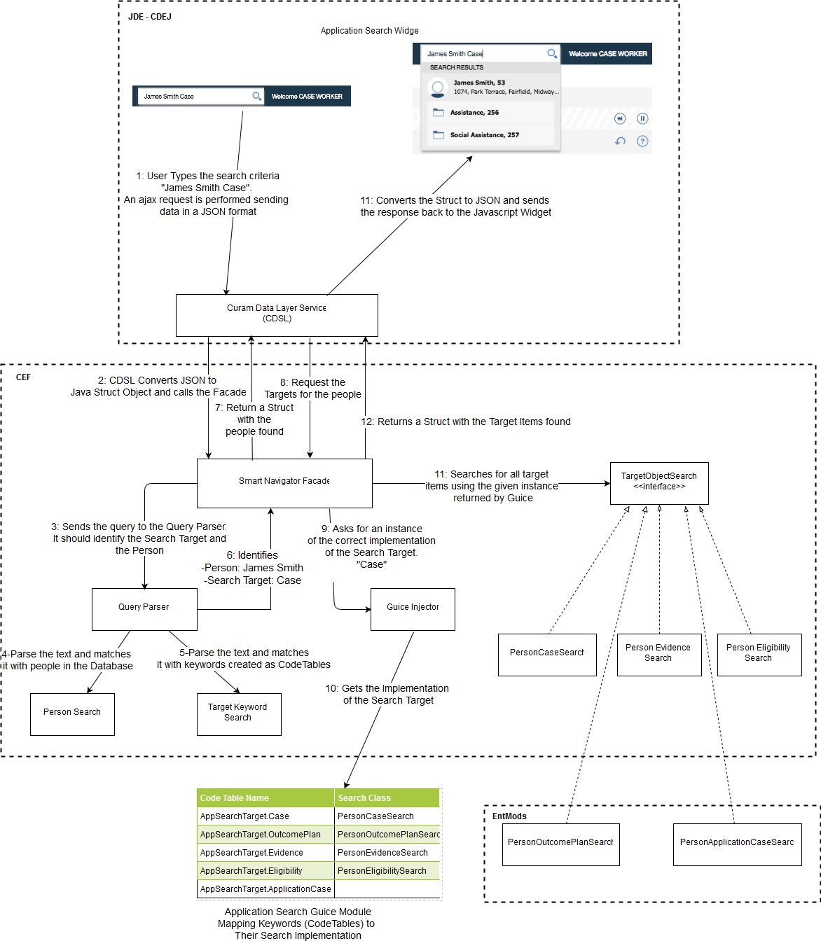
Figure 1. High Level Diagram

Design Details

Application Search field

Current application search field overview

The existing application search itself does not perform any searches. When the search button is clicked, the query terms are sent to a configurable search page that is opened in a new tab. It is up to the applications to create their own search pages and list the results in any format they want.

The application search is defined based on the element application-search within the application configuration file (*.app). The applications configure the UIM page that will be displayed when the search button is clicked.

In its simplest form, the application-search element requires the attribute default-search-pages, which is used when there is only one type of search and no combo box is displayed. This is a reference to the UIM page that will be rendered when the search button is clicked.


Figure 2. Simple search.

The search-pages element can be used within the application-search element when multiple search types are required, e.g. Person, Case, or types of search, e.g. Person Surname, Person Reference Number. Each search type is listed in a combo box and a different UIM is called depending on the selected entry in the combo box.


Figure 3. Multiple search types.

  - Query search field

To improve the current application search user experience, the new search is going to show the results directly in the search field as the user types in. Also, the search intends to be more dynamic, being able to search for multiple targets at the same time, e.g. Search for a person and his cases, payments, evidence, outcome plans and so on. Every item of the list will be clickable and will lead the user directly to the item’s page.

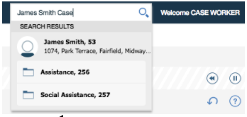
Figure 4. Smart Navigator displaying a person and all his cases.

The feature must be configurable to be turned on or off via administration. If turned off the Application Search will revert to the existing feature which will continue to work as expected.

To support the new autocomplete feature, a Curam Data Layer Service (CSDL) servlet is used to invoke the Smart Navigator Façade API and return the results in an expected JSON format.

The search field calls the CSDL servlet using Ajax as the user types the criteria and then display the results in a drop-down list. To avoid calling the servlet on every keystroke, the onKeyDown javascript events will be grouped into a single event and the API call will be made once every 500ms.

The primary item of the search results is the person. The people will always be listed on the first level of the results list. If the user types a search target keyword, such as case or evidence, the results are going to be grouped per person and displayed as a sub-level of the person.

Every item of the list contains a direct link to its page. For example, If the user clicks on a case of the list, the case’s tab is opened. Items that don’t have a configured tab (*.tab) for the destination, will be listed but a warning indicating the missing tab will be posted if an attempt is made to open them. In addition some items may have more than one tab configured for them in this scenario a preferredTabs attribute is configured on the item to define which one to select.

The results are going to be limited by 6 top level items with associated sub items. If the criteria returns more items, a link will be displayed allowing the user to click to see more items.

  - Mixing the old and new Application Search Field behaviors

To avoid impacts in the current application search, the search-pages element still works with the Smart Navigator. If an application sets the search-pages element and the Smart Navigator is active, the Smart Navigator will be listed as an option (figure 3).

The Smart Navigator takes precedence over the default-search-pages. If the user still wants to keep the previous default search, the default-search-pages needs to be configured as a new search-pages element to work along with the Smart Navigator.

Application Search CDSL API

To support Smart Navigator, a new facade is implemented to perform the actual search rather than delegate the search to a separate UIM page. The façade provides a new API which is called via CDSL. The CDSL converts the JSON from front end Ajax requests to Java Structs and calls the Façade.

The API is going to receive the text query entered in the search field, parse and call the appropriate search methods. The results are going to be returned to the client in a JSON format.

The search algorithm parses the text to identify if there is a person to search and if there is also a search target, e.g. Case search, Outcome Plan search. After the parsing, the algorithm’s next step is to perform the target searches for each person found.

For example, if the user types “James Smith Case”, the parser would identify James Smith as a person and “Case” as a search target. After that, the algorithm links the target search to the person, in other words, it searches for all cases of James Smith.

There are two types of Search Targets REQUIRES_PERSON and NO_REQUIREMENT.

The search is broken into two parts that correspond to API calls. Note the use of the word item below denotes something that can be displayed in the UI. Person items would be for example the “James Smith” person page. Non person items represent targets of type NO_REQUIREMENT for example the Register Person Page. While target items represent targets of type REQUIRES_PERSON for example the Evidence page for James Smith.

search - returns Person items and a list of corresponding targets or non Person items

searchForTargetsOfPeople - returns the target items for the given people

(2.1) Person Search

The first part of the query parser is to check if there is a person in the query text. That is done by reusing the existing core’s person and alternate id searchs. Given a text, it tries to search by the first name and surname, date of birth or alternate id.

A search looking for a person’s alternate id is first performed for every word of the query text. If there are no results from the alternate id search we continue with the search by name.

The search by name requires at least two words that are used as the first name and last name. It always tries to match the longest sequence of words, meaning that if there are more than two words in the phrase, it first uses two words and adds more words if the previous search returns a person.

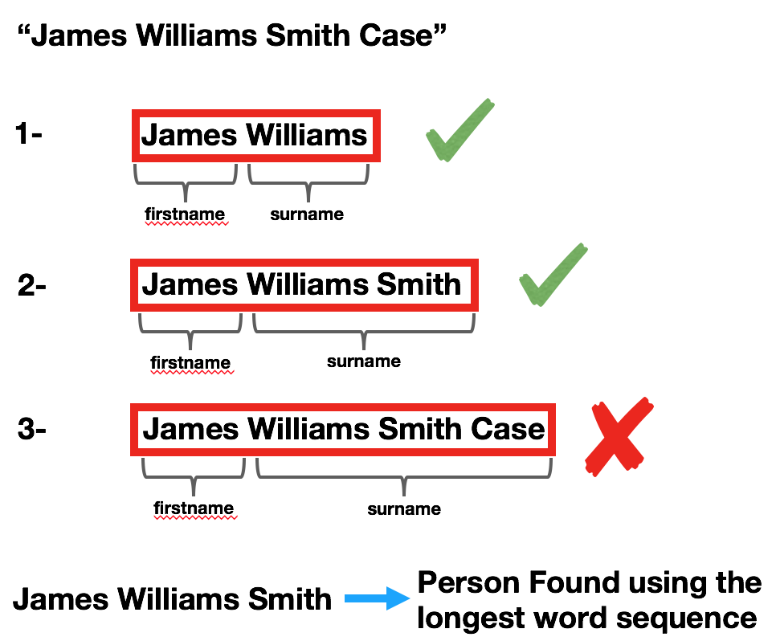
Figure 5. Person Search matching the longest words sequence

(2.2) Search Targets

The second part of the query parser is to identify the search targets, which are extra entities the user wants to search beyond the person.

The search targets represent screens of the applications. They are usually, but not always, linked to a person, e.g. Person’s Cases, Person’s Evidence, Person’s Eligibility, Person’s Outcome Plan. Examples of search targets that are not linked to a person could be Register Person or Search Cases.

The query parser searches for a set of keywords to define whether the word should be considered a search target or not. Every search target should have a list of keywords that represent it.

The Code Table infrastructure is used to define the list of search targets keywords because of its flexibility to create hierarchies, the ability to translate the code table values to any language and also it is easy to add, remove or rename keywords.

Two code tables are going to be used:

AppSearchTarget: Code Table defining the search targets.

AppSearchTargetKeyword: Child Code Table that defines the keywords from each search target.

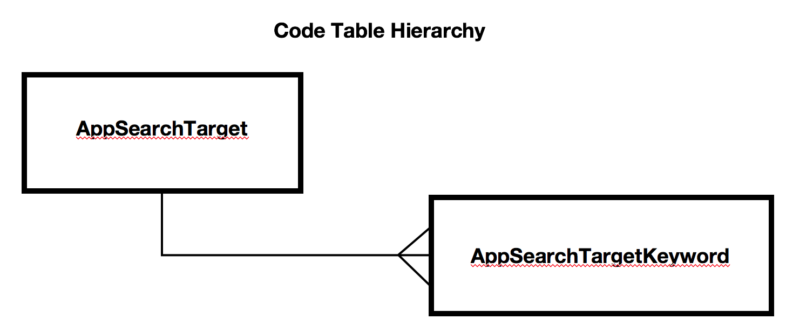
Figure 6. Code Tables used to link keywords to search targets

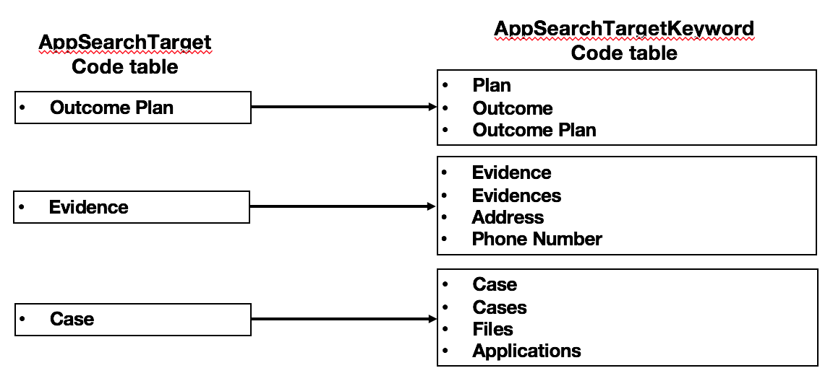
Figure 7. Examples of code table values

For the OOTB version, it is not planned to create search targets for every screen in the application. We will support only the following search targets:

Person’s Cases

Person’s Outcome Plans

Person’s Evidence Pages

Person’s Eligibility Pages

New search targets can be easily added as part of the search customizations.

Once the query parser is complete, the People items are found and the search targets identified the search method returns with these results. Note this method can also find and return non People items for example Register Person.

(2.3) Calling the Search Targets

If People and search targets are found by the search method the client will make a second call to searchForTargetsOfPeople to get the target items for the given people. This two phase process is implemented in order to reduce the processing required during the search for the people target items. In the scenario where we find a large number of people it is useful to only need to search their corresponding targets on demand.

Every search target must have a class that implements the interface TargetObjectSearch. The search target class will actually perform the search for its specific object.

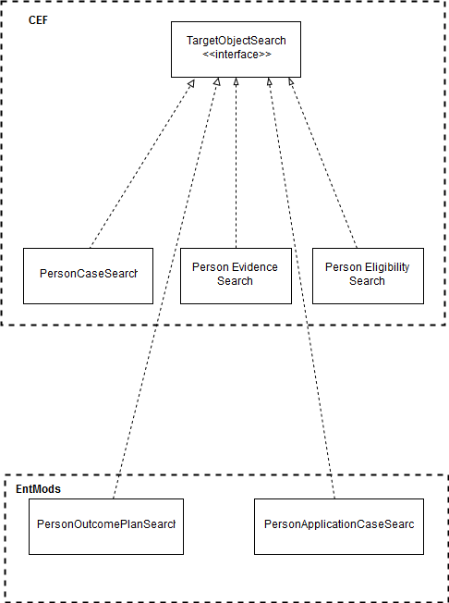
Figure 8. Every search target must have a search implementation class

The search algorithm uses Google Guice to inject the correct implementation of the search target given the code table found by the query parser.

Once the search target has defined its code table values and implemented the TargetObjectSearch interface, the next step is to link them together by creating a Guice module.

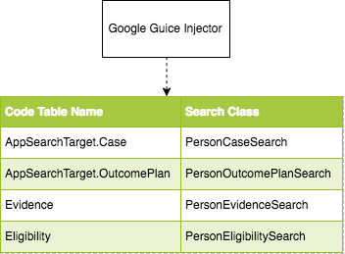
Figure 9. Google Guice Module - Binding code table values to the classes

(2.4) API Response

The API returns a JSON listing the people and actions found. Every item should have its own description and URL. We are showing below the responses from the query string “james smith case”.

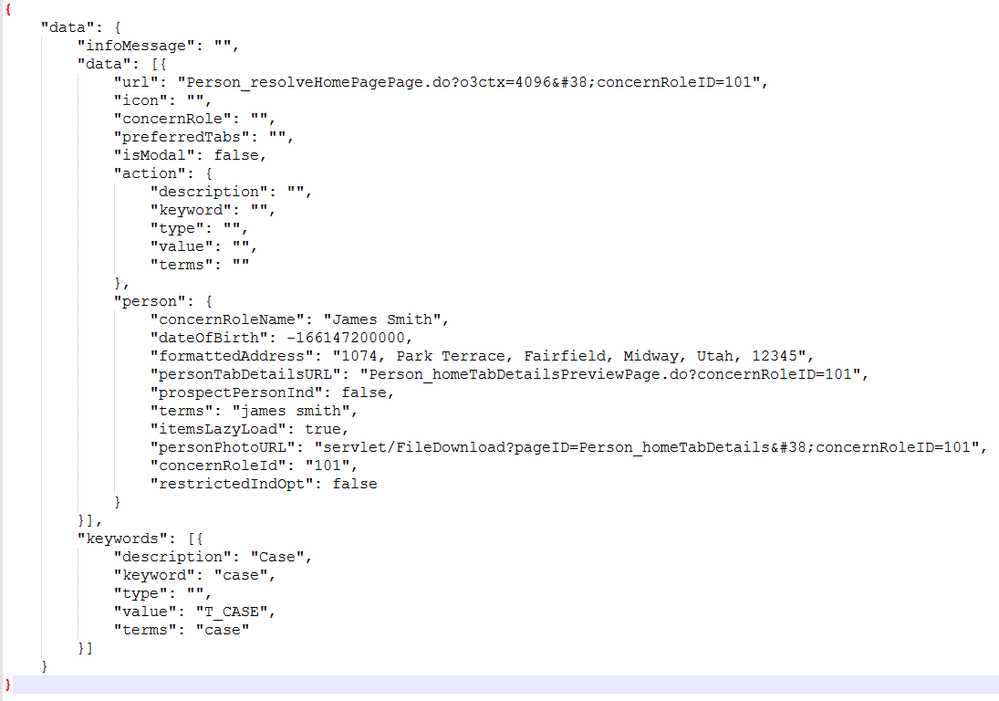
Figure 10. Example of a JSON returned by the API in response to search call

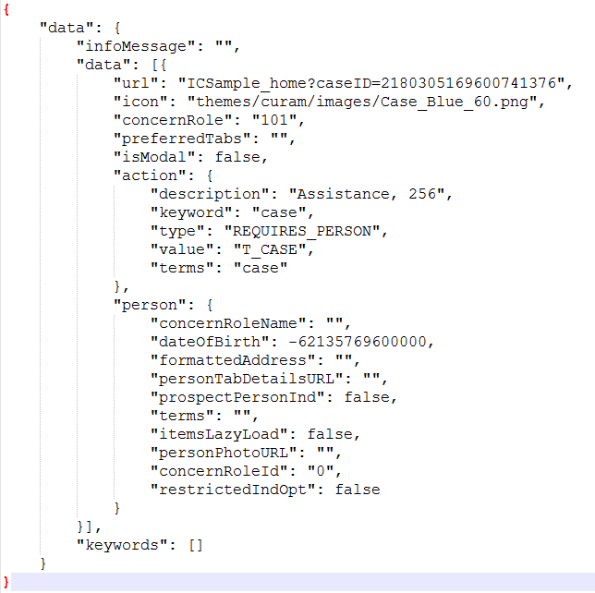
Figure 11. Example of a JSON returned by the API in response to searchForTargetsOfPeople call

Security

(3.1)Authorization
Authorization is carried out using existing controls. Every target that the user can be directed to must implement an interface TargetObjectSearch that includes a String getSIDName() method. The method returns an SID that is used to check if a current user has access to the search results returned. The SID is typically set to the display facade method signature that is used on the page that the search results link to. For example this method in a search target that searches integrated cases returns "IntegratedCase.readCaseDetails1", which is the facade display-phase method used on an integrated case's home page. Before calling any search target implementation a check is carried out by calling Authorisation.isSIDAuthorised(searchImplementation.getSIDName()). If this returns false a message is reported to the InformationManager which is then be surfaced in the UI. If true the implementation is called and the results returned.

(3.2) Validation
No additional input validation is done on the client side with this implementation. Input validation is left to the existing infrastructure.

Project Impact

As an optional feature, if the Smart Navigator is not turned on in the application configuration file (*.app), the application search should work exactly as it is currently.

There will be no impact to existing applications.

Implementation Details

Application Search Field

Currently, all the implementation of the application search is done using its renderer java class ApplicationSearchPanelRenderer and its javascript dojo module SearchMultipleTextBox in the JDE codebase. The current application search implementation will be adapted to add the Smart Navigator new features to the current implementation.

Basically, the Renderer will verify whether or not the Smart Navigator is active by reading the application properties. If it is active, then the renderer will output the new Smart Navigator features.

When active, the Smart Navigator calls the facade API, using ajax, as the user types the query text using the javascript event onkeyup. To avoid calling the server on every keystroke, the search input will make use of debounced functions to call the server. Basically, debounced functions are not executed when invoked, they group multiple function calls and wait for a configurable duration before executing only once; each new execution restarts the timer.

Every item returned by the facade API should have an URL to its page. The Smart Navigator makes use of existing javascript functions within CDEJ to open the links in new tabs.

Smart Navigator Facade API

The facade API implementation is created as a new component in CEF called SmartNavigatorFacade. The reason this component is not in JDE is that the API will use existing methods in CEF to search for person, case, evidence, eligibility and outcome plan.

The CDSL is used to convert to and from JSON when invoking the relevant methods on the SmartNavigatorFaçade.

All the search operations executed by the API (person search, case search, outcome plan search) are reusing existing searches in the platform.

The search algorithm makes use of Google Guice bindings to locate the appropriate java search class instance. It means that any OOTB search can be replaced by a custom Guice module.

Customization

Keywords

Every search target is configured as code tables using the table name AppSearchTarget.

For each search target, a set of keywords is registered as child code tables using the table name AppSearchTargetKeyword. Apart from the OOTB keywords, more custom keywords can be added to the search target. For example, the search target “Case” may have the OOTB keywords “case” and “cases”. The admin user can later add the words “files” and “integrated case” as new keywords for the search target.

Adding new Search Targets

New search targets can be added at any point by following 3 steps:

Create code tables to define the search target and its keywords.

Create the search java class implementing the interface TargetObjectSearch

Create a Google Guice module binding the code table name to the new java class name

The above is the standard Curam approach for allowing customers to customize or extend the Curam application.

Overriding the current searches

Any search type in the OOTB Smart Navigator can be replaced by a custom search implementation. If the user wants to replace the current person search with a custom Apache Solr search, for example, this could be done by creating a new Guice Abstract Module binding the new search implementation.

Development Considerations

Repositories (RTC)

TI-Master-IntelligentSearch: The application banner search renderer code.

CEF-Master-IntelligentSearch: The Smart Navigator Façade API code, delivered under the component SmartNavigator.

SPMEntMods-Master-IntelligentSearch: Used to implement new search targets Outcome Plan and Application Case

Deployment Considerations

There are no special deployment considerations, we are leveraging the existing Curam Infrastructure.

Test Considerations
All the code, java or javascript, must be fully covered by unit tests.
The feature needs to operate correctly on all supported resolutions on a desktop device and in tablets. For desktops the supported resolution is 1366x768 as stated in the release notes for the version 7.0.0.0. For tablets it is 1024x768.
Accessibility verification tests:
- AVT 1 - Use of automated Testing Tools: In Curam case we should be using RPT-DAP.
- AVT 2 - Manual Testing - High contrast, keyboard, focus, browser zoom.
- AVT 3 - JAWS Screen Reader Testing.
- AVT 4 - VoiceOver Screen Reader Testing.

Documentation

The current application search configuration documentation needs to be updated with the topics:

New attribute added to the application-search element

How the Smart Navigator works

How to customize the Smart Navigator
The current documentation is located at the Application Search current documentation.

Historical Information

The first proposal of the Smart Navigator used the IBM Bluemix Watson Conversation Service to parse the text. Even though it worked very well, we decided to replace the service with on-premises technology to avoid extra costs to the clients. Also, we found that we may had to face some problems with HIPAA compliance.

All the details about the IBM Watson powered Smart Navigator can be found in the R&D Community.

Architectural Decisions

AD001 – Rest API packaging structure
Architectural Decision | Rest API packaging structure | ID | AD-001
Issue or Problem Statement | Where does the REST API must be implemented?
Assumptions | The Rest API needs to be at platform level in order to reuse existing search methods, such as search for person, case, evidence and eligibility.
Motivation | -
Alternatives | - Deliver the Rest API in the core component of CEF.  - Create a new component in CEF exclusively to the Application Search.
Decision | #2
Justification | After a discussion with the platform team, we decided to create a new component called ApplicationSearch to manage all the code related to the Rest API.  The decision was made based on the fact that the core component has become hard to maintain and must be treated as a miscellaneous component.  Also, recent enhancements such as Dynamic Evidence and Evidence Share used the same strategy.
Implications | -
Status | Closed
Date | OCT-2017

Architectural Decision | Replace REST API with CDSL | ID | AD-002
Issue or Problem Statement | REST API is not working as expected in the internal application. Issues with single sign on. Needing to login to the REST API separately. We need a mechanism to support the Ajax calls used in the front end.
Assumptions
Motivation
Alternatives | - Continue investigating the existing problems with REST in conjunction with the REST team  - Investigate other options available in existing Curam infrastructure
Decision | #2
Justification | Following investigation it was discovered that Curam provides its own Curam Data Layer Service. The CDSL converts the JSON from front end AJAX requests to Java Structs and calls a Façade. It has the added benefit of already being part of the Curam infrastructure so we can leverage its existing security compliance. Whereas use of REST would have required a more detailed security review. Currently we don’t have anything in the internal Curam application using the REST infrastructure. However CDSL is already being used in production by Outcome Management.
Implications | -
Status | Closed
Date | Jan-2018

